**Exercise 7: Financial Forecasting**

ForeCast.java

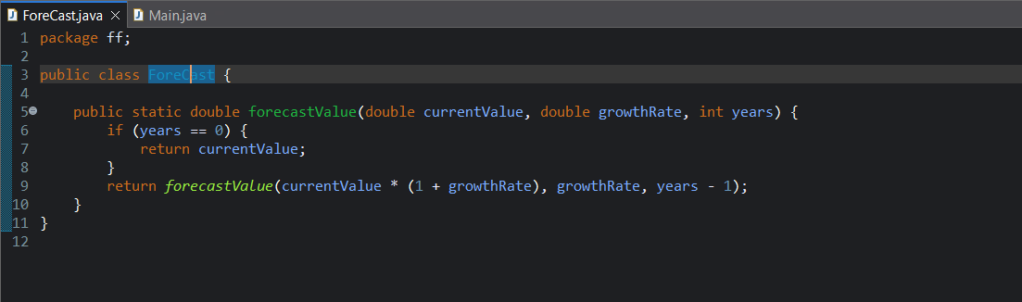

Main.java

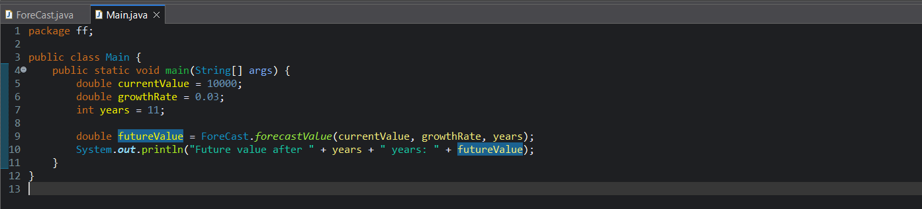

**Output**:   
  
